**ULTIMATE WIND MILL**

**AREA OF RELEVANCE :** MECHANICAL AND ELECTRICAL

**TYPE OF PROJECT :** ELECTRICITY PRODUCTION (RENEWABLE AND NONCONVENTIONAL SOURSE)

**ABSTRACT :**

The main concept of this experiment is to produce electricity from wind flow with low frictional loss. When the air flows through the propeller connected to the armature, starts to rotate.When the armature rotate, the NdFeB magnets also tends to rotate that causes flux change with the stator coil. The emf flows with the direction of Flemings right hand rule.

It consists of stator , rotor, propeller, blocker.

The stator model consists of permanent magnets which is used to levitate the armature equipped with neodymium magnets. Stator coil has 26 gauge copper coil of 1000 turns and placed at the middle of the armature.

The rotor model consists of ndfeb magnets with two permanent earth ring magnets with a sharp edge.

A self designed propeller is connected to the rotor that Operates at very low or high wind flow rates, Low starting torque is needed for the rotation.

Blocker is a glass slide placed at the end of armature to oppose the forces caused by wind and the stator magnetic field , that is the only thing to produce friction between the sharp edge and the slide.

**UNIQUE FEATURES :** More efficiency of power output , Less friction(loss), Operates at low wind flow rate, high efficiency, less internal resistance, maintenance free, internal gearings are not needed, rotates at high speed.

**Materials used :**

1. Permanent magnets
2. NdFeB magnets
3. Ring magnets
4. Coil
5. slides
6. 30 LED
7. Propeller
8. DC motor

**DELIVERABLE :** MORE ELECTRICITY CAN BE DRAWN.

**EXISTING APPROACH :** MORE FRICTION LOSS DUE TO INTERNAL SPEED UP GEARINGS.

**MY APPROACH :** TO REDUCE THE FRICTION LOSS.

**PROPOSAL DIFFERENCE ON ORIGINALITY :** APPLICABLE IN REAL LIFE

**PERFORMANCE :** HIGH EFFICIENT EVEN IN LOW WIND FLOW.

**COST FOR BENIFIT :**

**APPROCHES TO SOLVE PROBLEMS :** Magnetic levitation principles.

**MODELING :**

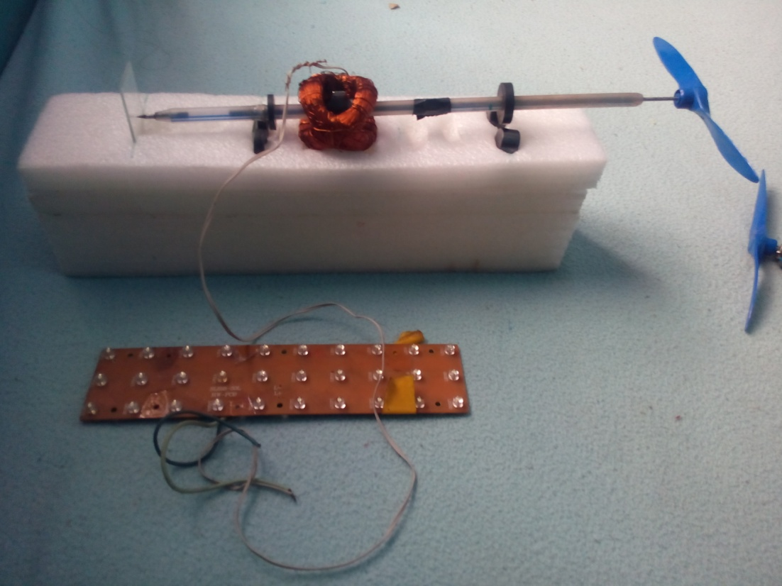

**IMPLEMENT DETAILS :**

1. **Flemmings right hand rule : (Generator)** When the flux changes in the conductor linked with the coil ,emf is induced in it. While stretching our fore, middle, thumb fingers mutually perpendicular to each other, the fore finger indicates the direction of force, middle finger indicates the direction of current, thumb indicates the direction of motion.
2. **Magnetic levitation :** When same magnetic poles are positioned nearer to each other magnetic repulsion takes place and When opposite magnetic poles are positioned nearer to each other magnetic attraction takes place.

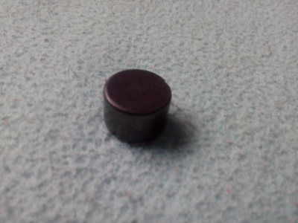 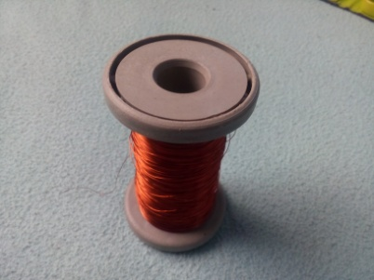 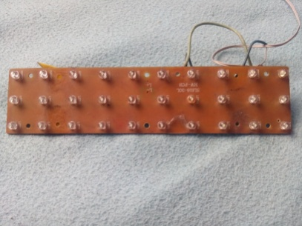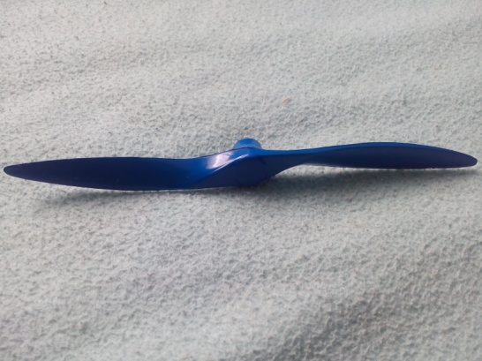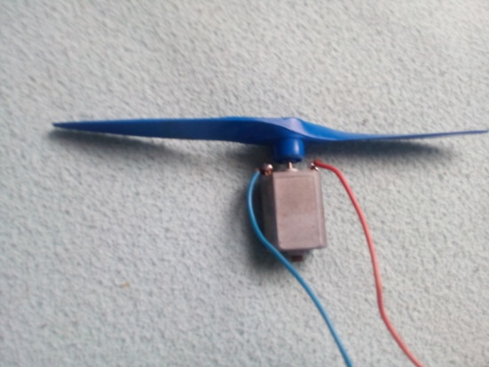

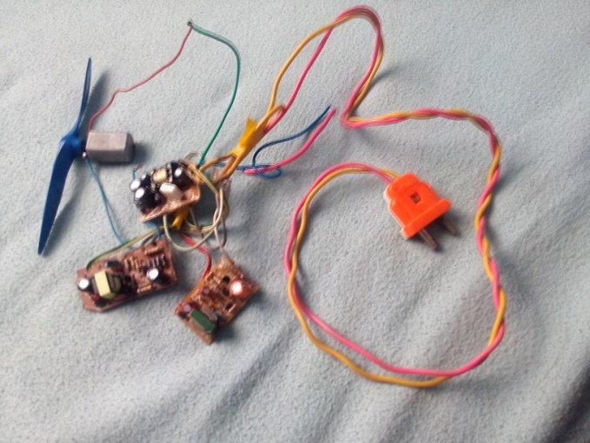

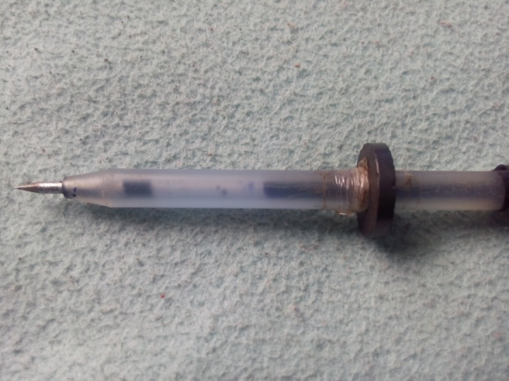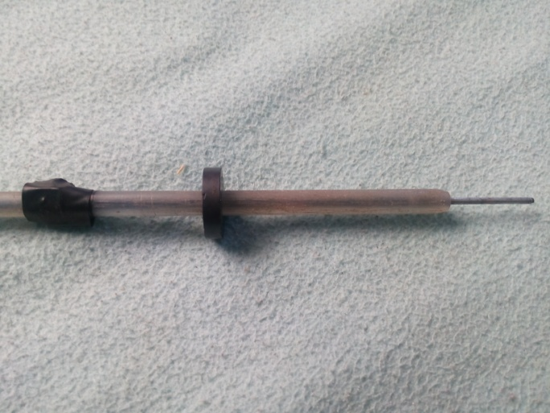

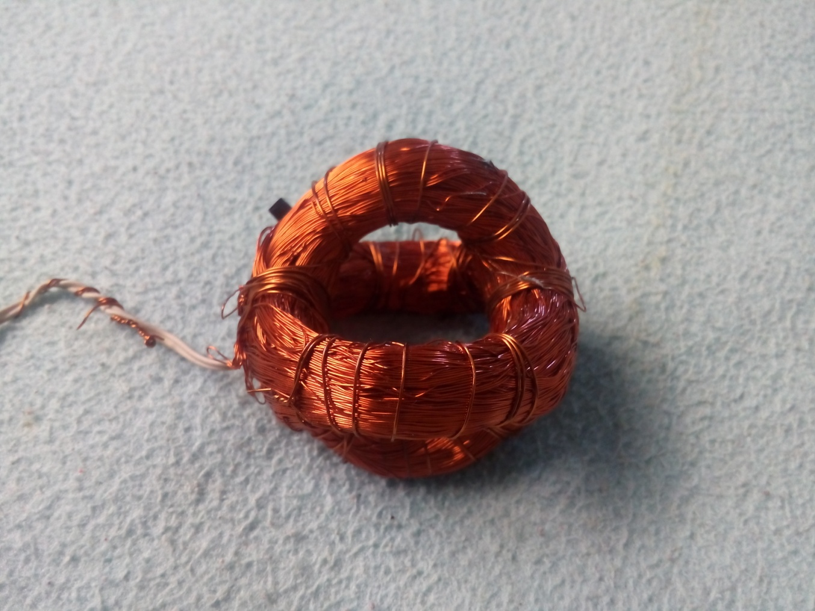 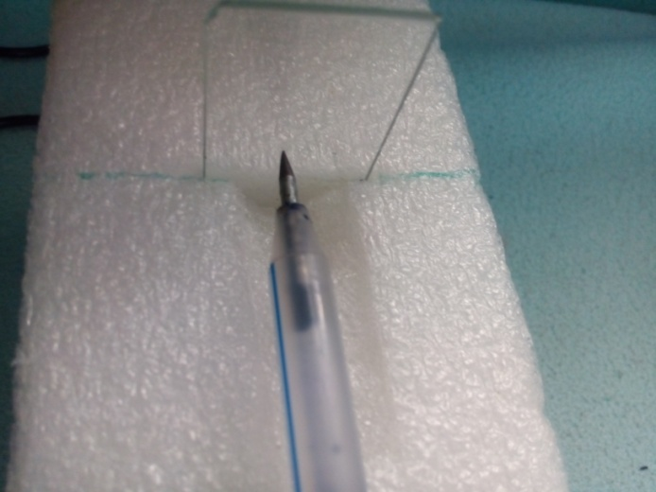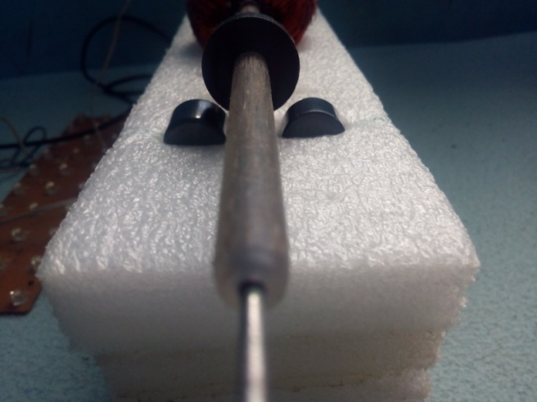

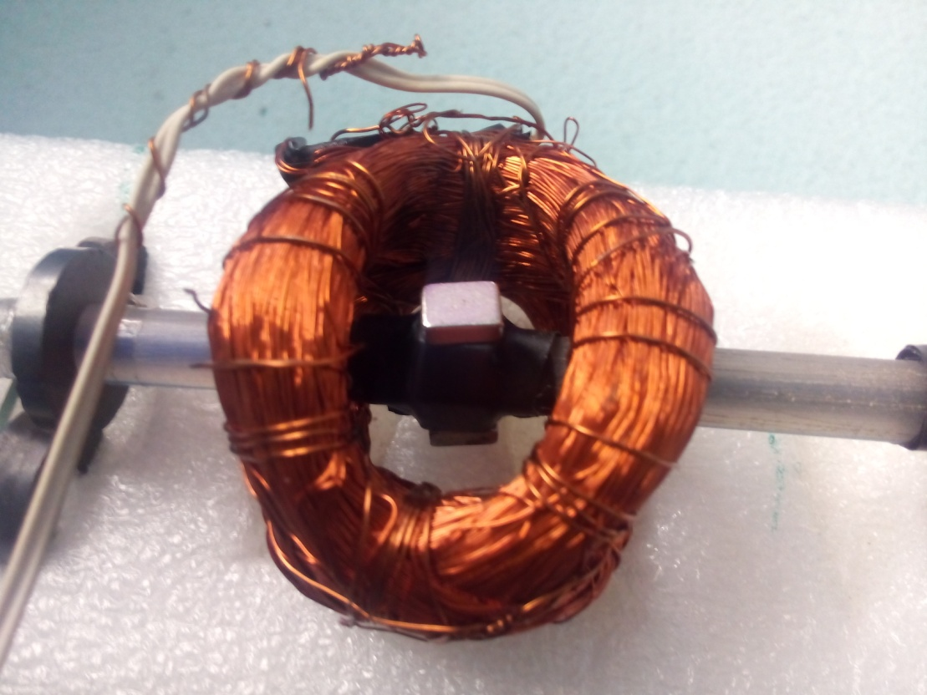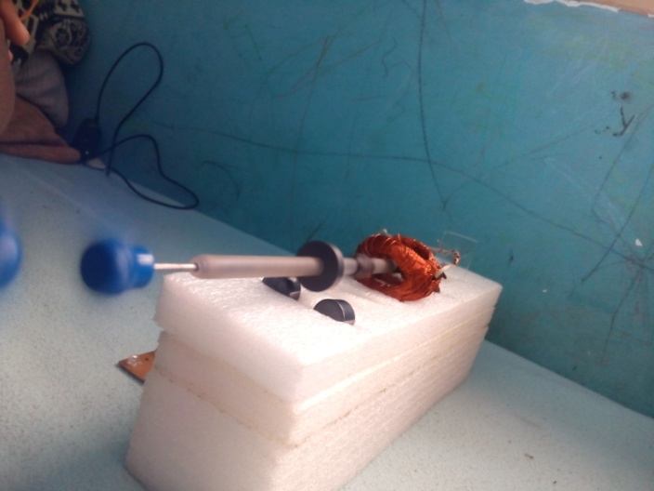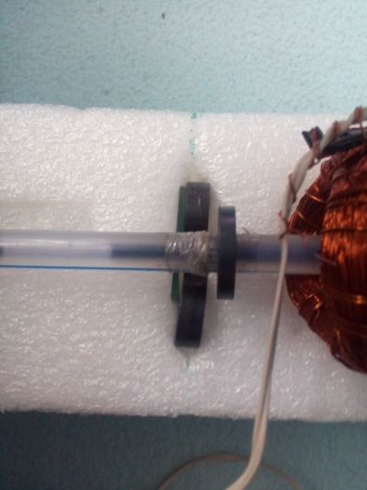

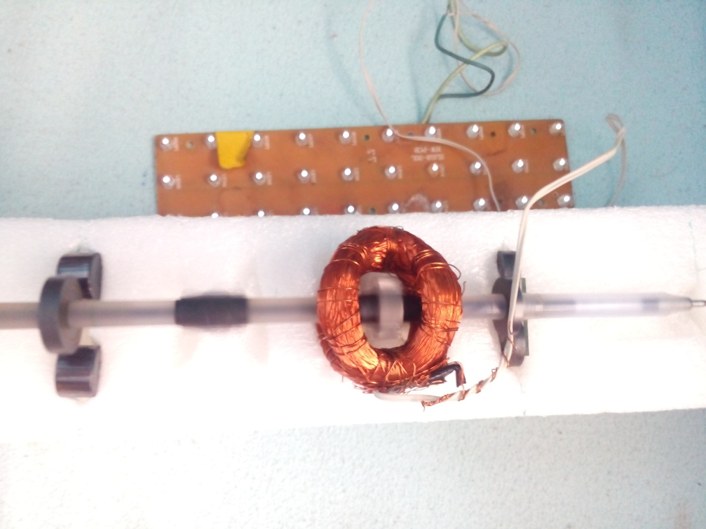

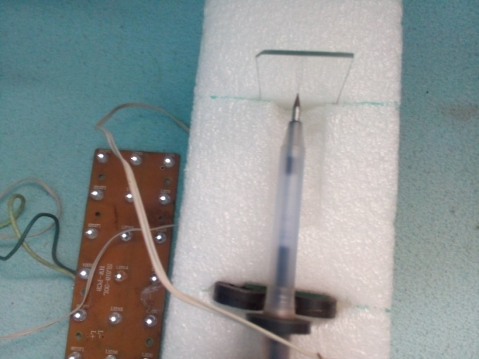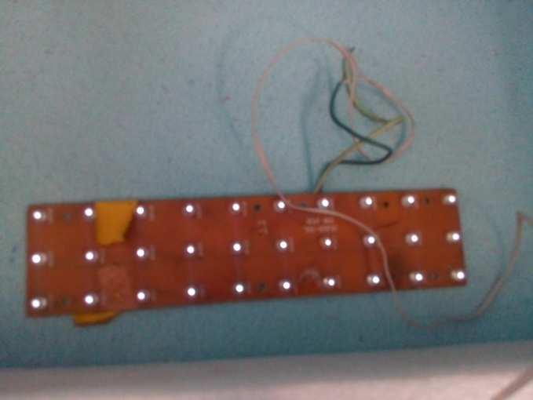

**COMPONENTS FOR TESTING :** multimeter,tacho meter, anemometer,CRO.

**PROGRESS ON TESTING :** the magnetic fiels intensity and coil turns and thickness is varied to give respective output voltage.i got 0.2 volts initially and finally i got 3.3 v.

**RESULT :**

There by the friction is very less between sharp point of rotor and slide (stator). From my experiment 3.3 volts is obtained after rectification.

**INFRASTRUTURE REQ :** a wind flow area of wind flow velocity 18kmph.

**PROBLEMS :** the device is needed to keep at high elevation for high wind flow velocity.

**DIS ADVANTAGES :** HIGH INITIAL COST, CONSTRUCTIONAL COMPLEXITIES IN PROTOTYPE.

**RESEARCH** – ON APPLICATION OF MAGNETIC FIELDS ON LEVITATION.

**BUDGET ESTIMATE** : RS-1000 (for my model)

**CONCLUSION :**

Through this experiment we can gain more efficiency of power output and need not to pollute the environment, eco friendly , manpower is not needed, Less friction(loss), Operates at low wind flow rate, high efficiency, less internal resistance, occupies less space, maintenance free, less propeller length, less disturbance to migrating birds, gearings are not needed, rotates at high speed.